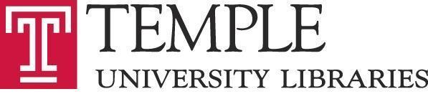

ACADEMIC ASSEMBLY OF LIBRARIANS
STEERING COMMITTEE

TUESDAY, November 19, 2019
2:30 PM
Charles Room 364

AGENDA

Attending: Leanne Finnigan, Brian Boling (Chair), Sarah Jones, Stefanie Ramsay (recording), Katy Rawdon, Joe Lucia (ex oficio)

- Approve Minutes of October Steering Committee Meeting
  - Approved.
- Report from PARA committee, Kristina DeVoe
  - Initiated process last month by organizing materials, setting PARA calendar, sharing calendar with Library Administration, getting list of eligible candidates from Library Administration.
  - 4 candidates this year: Appel, Galson, Ramsay, Toner, Shanley (regular appointment).
  - Notifications to candidates will be sent later this week/early next week. Candidates will have until January 24 to submit applications. Application process will be moved online.
  - Will return to AAL to update us in Spring 2020 with any changes needed to procedures after transitioning to online process.
  - Report should live in Confluence and AAL website.
- Dean’s report
  - More art coming into building. None are permanently selected. Goal is to select wide-ranging works and art that enhances aesthetics of building. Art is gifted to University as a whole. Joe does not know conservation paperwork, assuming that University has some responsibility over ongoing maintenance.
    - Architects, donor, curator involved in decision-making. Not sure about who is involved on University side.
    - Loose process.
  - Visit from University of Delaware last week.
  - Working on strategic planning activity, no substantive updates yet.
- Old business
- New business

Adjourned 3:12pm.
12/17/19 BB
12/17/19 JL

