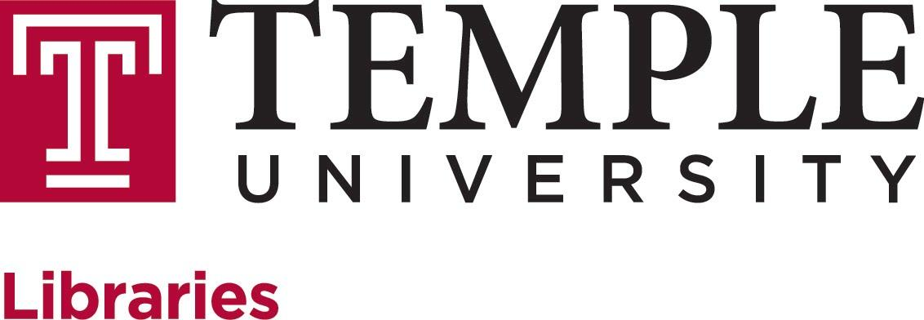

ACADEMIC ASSEMBLY OF LIBRARIANS
GENERAL ASSEMBLY
MINUTES
Tuesday, September 11, 2018
2:00 PM
Paley Library Lecture Hall

Attending: Rachel Appel, Steven Bell, Brian Boling, Jasmine Clark, Kristina DeVoe, Matt Ducmanas, Erin Finnerty, Leanne Finnigan, Gabe Galson, Andrea Goldstein (chair), Josue Hurtado, Tom Ipri, LaTanya Jenkins, Sarah Jones, Joe Lucia (ex officio), Jill Luedke, Urooj Nizami, Stefanie Ramsay (recording), Katy Rawdon, Fred Rowland, Rebecca Schmidt, Cynthia Schwarz, Jackie Sipes, Matt Shoemaker, Margery Sly, Holly Tomren, Kim Tully, Nancy Turner

I. Approval of Minutes of the May General Assembly meeting
- Minutes approved.
II. Election for PARA to replace Jim Bongiovanni, 1 year (Kohn, Tully)
- Jackie Sipes elected to PARA for one-year term.
III. Dean Update
- Report to Leadership Team on communication: some concerns raised by feels like we are using all of the tools we can (strategic steering teams, slack, WebEx, Confluence). The concerns raised were around personnel changes.
- Staff wanted to know more about the new building, but there are some things we don’t really have answers for yet. Considering sending biweekly updates to keep everyone aware.
- Some questions include: How do we fill ASRS and how does that process work? Are we using student labor to fill ASRS? Won’t have test load to actually validate assumptions until March. Is it reasonable to have staff task team? Will we close Paley Library? Sections of Paley? How do we deal with circulation? How does that impact study space? Will people be able to access the space in the summer? Move management team thinks we can do everything from May 15-July 30. Move consultants don’t understand how complicated Special Collections move is. Working on mapping realistic expectations. Will there be mandatory closing dates/weeks off?
  - Would like to have some answers by Thanksgiving.
- Building updates: digging into ASRS set-up and details; beginning systematic outreach to faculty to involve them in programming and events; working with Sara on first-year series of events (one of the themes with be “History and Future of the Book”, drawing from Special Collections).
- Other updates from the library include institutional repository discussions, Temple on OSF, Fund for Data Access.
IV. Annual Report-Faculty Senate Library Committee, Goldstein for C. Shanley
- Joe facilitated both meetings and gave update on new library building. No minutes were taken.
V. New Librarian introductions
- Gabe Galson (Cynthia Schwarz)-- started in June 2018, been at Temple since 2013.
- Tom Ipri (Steven Bell)-- started in September 2018, coming from St. Joseph’s.
VI. Old Business
- No old business.
VII. New Business
- Leanne and Rebecca are on joint faculty-senate TAUP committee on childcare. Committee will be putting together symposium on childcare October 24, 3:30-5:30 in Student Center that is open to everyone (non-TAUP, students, staff). Looking for help with greeting, marketing, etc. Contact them if you are interested.
VIII. Adjournment.

AG
JL

